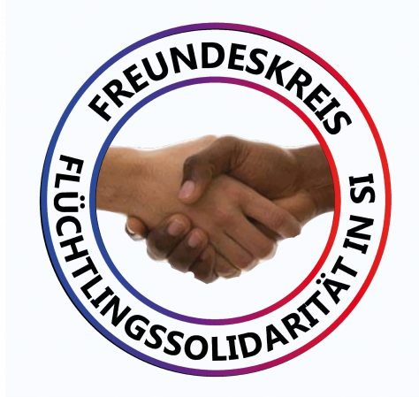 | 11-point program for the Circle of Friends of Refugee Solidarity  in SI (Solidarity International)  Contact us: info@freunde-fluechtlingssolidaritaet.org

- The „Circle of Friends of Refugee Solidarity“ is a non-party affiliated and self-organized association of refugees and activists of the democratic and revolutionary movement in Germany, which fights against the reactionary refugee policy of the federal government and the EU. It is based on the rich experience of the self-organized Ellwangen refugees who, like Alassa Mfouapon, have fought and are resolutely fighting against the deployment of martial police or deportations.
- The Circle of Friends upholds fundamental democratic and social rights and freedoms, the right to flee and the recognition of the specific oppression of women as grounds for asylum.
- The Circle of Friends supports a progressive and forward-looking refugee policy which fights against the causes of flight , not against the refugees. This also includes an open discussion on social alternatives, including socialist alternatives. That is why racism and anti-communism have no place in the circle of friends.
- Members of the Circle of Friends help the persons concerned to organize themselves to advise and assist each other: to solve problems such as the recognition of refugee status/asylum seeker, to exercise their rights vis-à-vis the authorities and the courts, to seek housing, to reunite families, to receive medical and legal support, etc. They organize solidarity (e. g. legal assistance and accompaniment) and protest against imminent or complete deportation and politically motivated criminalization.
- They advise the self-financing of these activities in the development of initiatives. The Circle of Friends itself is not a funding organization. It is financially independent and finances its work through active donation work and regularly reports on income and expenditures at its meetings.
- The Circle of Friends works at the national level with international relations.It works closely with all initiatives and organizations that agree on its objectives.
- The Circle of Friends works on the basis of this program. The groups of the federal states each elect a group of speakers. One representative from each of the federal states forms the nationwide speaker group. Nationwide there is a cashier and an auditor who are elected in a general meeting. For their own practical work, the groups can make sub-tills with an elected cashier.
- Further functions are public relations and press work as well as cooperation with other initiatives and organizations, which is carried out both regionally and nationwide.
- It gains one or more legal advisors.
- The General Assembly decides on the main projects, plans and working methods. Office holders are accountable for their implementation.
- Whoever becomes a member enters himself into the list of members. The annual fee is 10 euros for refugees / low income, 20 euros for employed people.
(Unanimously adopted at the founding meeting of the Friends of Refugees on June 27th, 2020)

