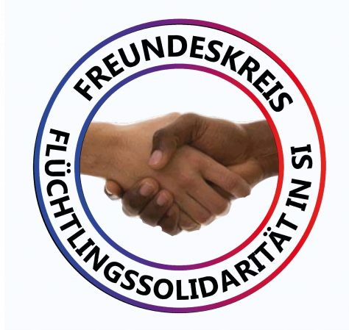 | Now we’re talking – 2.0!  20 points work program – decided on the  1st Refugee Policy Congress in Stuttgart on November 30, 2019
„Now we talk“ was the self-confident title of the 1st press conference of the refugees in Ellwangen after the martial, racist and illegal police operation against refugees in the state initial reception facility (LEA) on May 3, 2018. This work program is based on the work that has since been enormously developed and summarizes the main results of the 1st Refugee Policy Congress with “Now we are talking – 2.0!”.

- We see an increase in the causes of refugees around the world and are fighting the exploitation of the resources of the countries of the world, their people and nature, and in particular the tightening of the refugee policy of the rulers. We see this development – depending on the political point of view, in some cases – as inhumane, colonial or imperialist. We are preparing for dramatically increasing flows of refugees in the future.
- We are already realizing our social goal in our cooperation: There must be no first and second class people! We are realizing a paradigm shift: instead of profit and power – solidarity and cooperation in equality. Depending on the political point of view, we call our social goal a good life, democracy, freedom or socialism.
- We strengthen common ground especially against the legal development of the government in Germany and the EU and the dangers of fascism and war. We want to work together across borders in the future.
- Get organized! We have to work together permanently! Depending on the political position in the Freundeskreis Alassa & Friends, in refugee initiatives, in democratic or revolutionary organizations in the country in which we live.
- We network! The Freundeskreis Alassa & Friends is an integral part of Solidarity International (SI) and the Internationalist Alliance, and in the future will also be happy to use it in other refugee or trade union networks.
- We overcome fear! False friends advise us not to fight because it endangers us. We are prudent and protect one another, but follow the baseline: only those who fight can win!
- We don’t leave anyone alone: ​​Every visit to the authorities should be accompanied, every harassment and every discrimination must go public!
- We do active public relations work – every newspaper article should get the answer it deserves.
- We legally and politically demand the hard-won democratic rights and freedoms. Every process belongs on the street! We accuse the EU and the federal government of criminal cooperation with the Libyan regime.
- We call for the dissolution of all camps, „anchor centers“ or regulations that discriminate, harass and humiliate the refugees – whether in Germany, Libya, Italy or Greece.
- We place special emphasis on women-specific demands and interests and call for the recognition of gender-specific persecution as a reason for asylum.
- The mass of the world’s population is young – the struggle for the future of children and young people is specially important to us.
- Do not only work and fight together – cultivate meetings, getting to know each other, celebrating together and cultural events that strengthen our sense of community.
- hows civil courage! Boldly and committedly interferes with the bureaucratic and heartless processes! Take a stand against racism in the workplace, in the waiting room, in schools! Fights for the appreciation of brave fighters against racism and the causes of flight. We propose Alassa Mfouapon for the (Alternative) Nobel Prize.
- Let’s organize political education and enöightenment. We are and will be experts, pass on our knowledge and realize mutual learning – not least about the rulers and the functioning of the capitalist system in Germany. We clarify the reasons for flight and also realize solidarity with struggles in all our countries of origin and continents.

- This society is very rich – money is in abundance! It has to go where it is legitimately needed – and therefore also to us. We work financially independently, but also demand the financial strengthening of our work from our tax money, donations and funds.
- We defend ourselves against anti-communist intrigues that defame and make bad our cooperation of refugees with democratic and revolutionary forces in Germany. Beware of false friends who want to undermine self-organization. Zero tolerance against exclusion!
- We don’t want dependence on any party. Many of us are non-partisan, but all committed and honest members of parties are invited to work with us on an anti-fascist basis. We also encourage collaboration with unions and workers in the workplace.
- Let the words act, become troublemakers! Let’s start with it right now!
- The struggle continues until justice prevails.

The Circle of Friends of Refugee Solidarity looks forward to hear from you:
info@freunde-fluechtlingssolidaritaet.org
more informations at:
www.freunde-fluechtlingssolidaritaet.org

